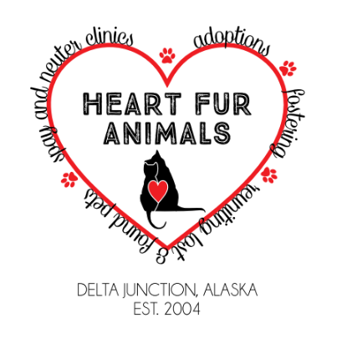
Dog Adoption Application
Heart Fur Animals (HFA)
Thank you for taking the time to fill out this application. Your information will remain confidential and used only as part of the HFA Animal Adoption Program.
PERSONAL INFORMATION (Please print):
Date: _________________
Name: __________________________________________________
Address: _____________________________________________________________________
City: _________________________________________State: ______ Zip: ________________ Home phone: ______________________ Work/Cell phone: ____________________________ Email: _______________________________________________________________________
How did you hear about us? If Facebook, what group or page? ______________________________________________________________________________ HOUSEHOLD INFORMATION:
How many people are in your household? Adults over the age of 21 (including self):______
Ages: __________ Children (under 21):______ Ages:______
Does anyone in the household have allergies to dogs? Yes No
Do you live in: HOUSE APARTMENT CONDO DUPLEX MOBILE HOME TOWNHOME
Do you: OWN RENT LEASE
How long have you been at this address? __________________________
If renting/leasing, are there pet restrictions? YES NO If yes, what are they? _______________
Landlord’s name___________________ Landlord’s phone____________________

List all of your current pets: Dog/Cat Breed Name Age M/F Altered? How long owned?

Do you have plans to move in the next 6 - 12 months?

Describe your yard: No yard Unfenced yard Partially fenced yard Completely fenced yard Height of fence: ________ Made of: Wood Chain link Brick Other _______________

ANIMAL EXPERIENCE/PREFERENCE:
How would you describe your level of experience with dogs? Check all that apply
Never had a dog Had childhood pet dog Had one or more as an adult
Have experience with powerful breeds
Have experience working with on-going medical problems with a personal dog
Have experience working at a boarding kennel/resort/pet sitting service etc.
Have experience working with behavioral problems with a personal dog
Have experience working in a veterinary hospital
Am a professional dog trainer
Have experience with: small dogs medium dogs large dogs

How many hours during the AVERAGE day will this dog spend WITHOUT a human? _______
Where will this dog be when someone is home? ______________________________________
Where will this dog be when alone? ____________________________
Where will this dog sleep at night? _______________________________________________
What situations do you feel unprepared for?
Excessive barking Destructive chewing Not housetrained
Digging Escaping Resource (food/toy) aggression
Shy, fearful, or undersocialized dog Not good with children
Not good with other dogs Not good with small animals/cats
Scratching/biting Administering medications
Providing on-going training Very high activity level Deaf/Blind dogs
GETTING TO KNOW YOU
Briefly describe your lifestyle and why you are wanting to adopt at this time: ____________________________________________________________________________________________________________________________________________________________
______________________________________________________________________________
Do you travel? If so, where do your pets stay if and when you travel? ______________________
______________________________________________________________________________
Are you willing to take the dog to obedience training? __________________________________
What, if anything, would lead you to give away your pet?
______________________________________________________________________________
Do you have the time to provide adequate love and attention to a pet? _____________________
Do you agree to provide healthcare for your pet if it gets sick? ___________________________
What veterinary clinic would you use? ______________________________________________
Do you agree to provide adequate food, water, and annual vaccinations for this pet? __________

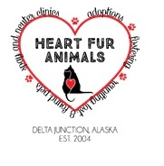
ADOPTION AGREEMENT
Name of Animal:____________________________________ Species: ___________________
Sex: _______ Age: _______ Breed: __________________________ Color: _______________
Upon the release of this animal to me, I will do the following:
- Provide him/her with humane/loving treatment at all times
- Provide proper and sufficient food, water, shelter, and identification
- Provide him/her with proper veterinary care, including but not limited to, proper immunizations.
- If an indoor animal, I agree that this animal will live indoors (not meaning the garage or basement) and to be outside only for periods of play/exercise and potty time. If circumstances change and I feel this animal can no longer live indoors, he/she will be returned to Heart Fur Animals (HFA).
- Provide him/her with daily exercise and a fenced yard if possible.
- If for any reason I am unable to keep the animal, I will not, under any circumstances, abandon the animal, but will contact HFA at 907-978-3328 immediately so that proper arrangements can be made for consideration to a new owner either found by myself or HFA or be returned to HFA.
- If behavior problems arise I will make all attempts to relieve the problem through professional advice and proper training, as well as notifying HFA of the problem.
- Upon transfer of ownership to me, I will pay the adoption fee of $300 (for an adult dog) or $350 (for a puppy, under the age of 1 year) which goes towards the medical care of the animal. This adoption fee is refundable in full if the animal is returned to HFA within the two week trial period, or partially if returned at a later date.

I accept the animal as-is and assume all risk and financial responsibilities of ownership. I agree to return the animal to HFA, making no charges of any nature for licensing, care, food or other services or items, if for any reason I am unable to properly care for or keep the pet. I understand that any sum of money I have given to HFA is to be used in caring for animals in the rescue program and is not refundable, unless the animal is returned within the two week trial period from the time of adoption.
I certify that the above information is true and accurate to the best of my knowledge. I understand that falsification of information can cause for denial of my application. HFA has my consent to investigate all the information provided in the adoption application.

Printed Name: _______________________________________

Signature: ___________________________________________ Date: _________________

