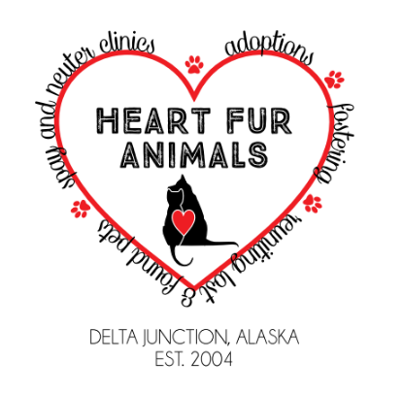
Cat/Kitten Adoption Application
Heart Fur Animals (HFA)
Thank you for taking the time to fill out this application. Your information will remain confidential and used only as part of the HFA Animal Adoption Program.

Name of cat(s) you are interested in adopting or describe what you are looking for:
______________________________________________________________________________
Reason for adopting?
o Personal Companion o Companion for a child o Mouser o For Friend/Relative o Companion for another pet o Other: _________________
Why do you want this particular cat, where did you first see him/her, and what drew you to them? ________________________________________________________________________
Adopter Information
Name: _________________________________________ Date: ________________________
Address:______________________________________________________________________
City: ________________________ State: _______________ Zip Code ___________________
Cell Phone: _______________________ Home Phone: ________________________________
Email Address: _________________________________________________________________
Do all household members know about and agree with adopting this animal? Yes / No
How many people live in your household? ___________________________________________
Do you have any children? Yes / No If yes, please list their ages: _____________________ How do your children behave around cats?
______________________________________________________________________________ If no, do you plan on having children soon? Yes / No
Is anyone allergic to hair or dander? Yes / No
Are you willing to permit a home check? Yes / No
Who will be responsible for the care of this animal? ___________________________________
Will you declaw this cat? Please be aware that declawing may cause behavioral and housebreaking problems. Additionally, if they ever go outside (on purpose or accidentally) they are completely defenseless. Yes / No
Housing
Type of Residence? House Apartment Mobile Home Townhome
Describe the area: Farm Setting Country City Suburban/Subdivision
How long have you lived at your current address? _____________________________________
Do you own or rent your home? Own Rent Live with friend/relative
If you rent, are animals permitted by landlord? Yes / No
Is a pet deposit required? Yes / No
Are there any size or breed restrictions, if so what are they?
______________________________________________________________________________
Please provide the name and number of your landlord:
______________________________________________________________________________

Day-To-Day
How many hours will the cat be left alone? __________________________________________
During what time frame? _________________________________________________________
Where will he/she be kept when alone? ____________________________________________
During the day? ________________________________________________________________
At night? ______________________________________________________________________
Where will the cat be kept? Inside Outside Inside/Outside
Would you consider a companion for your cat/kitten? Yes No

Previous Animal Experience
Do you currently own any cats? If yes, provide breed, sex, age, and current spay/neuter status.
______________________________________________________________________________
______________________________________________________________________________
______________________________________________________________________________
Any other types of pets? If yes, provide breed, sex, age, and current spay/neuter status. ______________________________________________________________________________
______________________________________________________________________________
______________________________________________________________________________
Have you adopted from a shelter/rescue before? If so, when or which group?
______________________________________________________________________________
______________________________________________________________________________

Have you ever rehomed or returned an animal to a rescue group, animal control, breeder, etc.? If yes, please explain in further detail.
______________________________________________________________________________
For pets you no longer have, where are the now? If deceased, how?
_____________________________________________________________________________
Animal & Veterinary Information
Vet Reference (Please include phone number):
______________________________________________________________________________
What features are you looking for in this pet? Please include size, energy level, personality, age preference, low-shedding/allergen-free, or other qualities you are looking for in this pet.
______________________________________________________________________________
______________________________________________________________________________
If you move, what are your plans for this animal and will you consider only pet friendly housing?
______________________________________________________________________________
Under what circumstances would you return this animal? (circle all that apply)
Cat Shedding Allergies Housebreaking Problems Financial Difficulties
Move Where Pets Aren’t Allowed Divorce/Marriage New Baby
Health Problems w/ Animal Bites/Becomes Aggressive
Other: ________________________________________________________________________

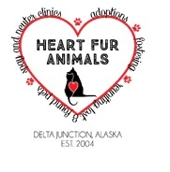
ADOPTION AGREEMENT
Name of Animal:____________________________________ Species: ___________________
Sex: _______ Age: _______ Breed: __________________________ Color: _______________
Upon the release of this animal to me, I will do the following:
- Provide him/her with humane/loving treatment at all times
- Provide proper and sufficient food, water, shelter, and identification
- Provide him/her with proper veterinary care, including but not limited to, proper immunizations.
- I agree that this animal will live indoors (not meaning the garage or basement) and to be outside only for periods of play/exercise. If circumstances change and I feel this animal can no longer live indoors, he/she will be returned to Heart Fur Animals (HFA).
- Provide him/her with daily interaction.
- If for any reason I am unable to keep the animal, I will not, under any circumstances, abandon the animal, but will contact HFA at 907-978-3328 immediately so that proper arrangements can be made for consideration to a new owner either found by myself or HFA or be returned to HFA.
- If behavior problems arise I will make all attempts to relieve the problem through professional advice and proper training, as well as notifying HFA of the problem.
- Upon transfer of ownership to me, I will pay the adoption fee of $175 which goes towards the medical care of the animal. This adoption fee is refundable in full if the animal is returned to HFA within two weeks.

I accept the animal as-is and assume all risk and financial responsibilities of ownership. I agree to return the animal to HFA if for any reason I am unable to properly care for or keep the pet. I understand that any sum of money I have donated to HFA is to be used in caring for animals in the rescue program and is not refundable, unless the animal is returned within the two week trial period from the time of adoption.
I certify that the above information is true and accurate to the best of my knowledge. I understand that falsification of information can cause for denial of my application. HFA has my consent to investigate all the information provided in the adoption application.

Printed Name: _______________________________________

Signature: ___________________________________________ Date: _________________

